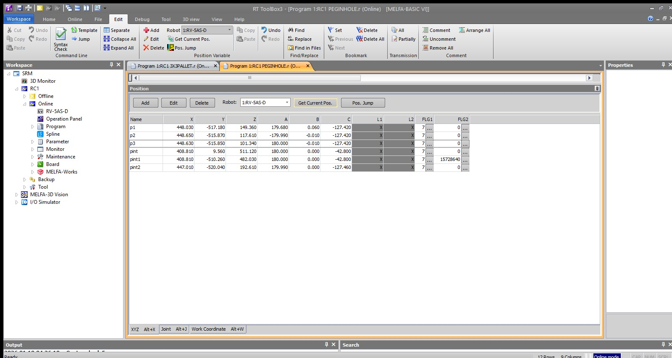
Figure 1: Position Variable table in RT ToolBox3 showing waypoint coordinates (pint series) and insertion points (p1–p3).
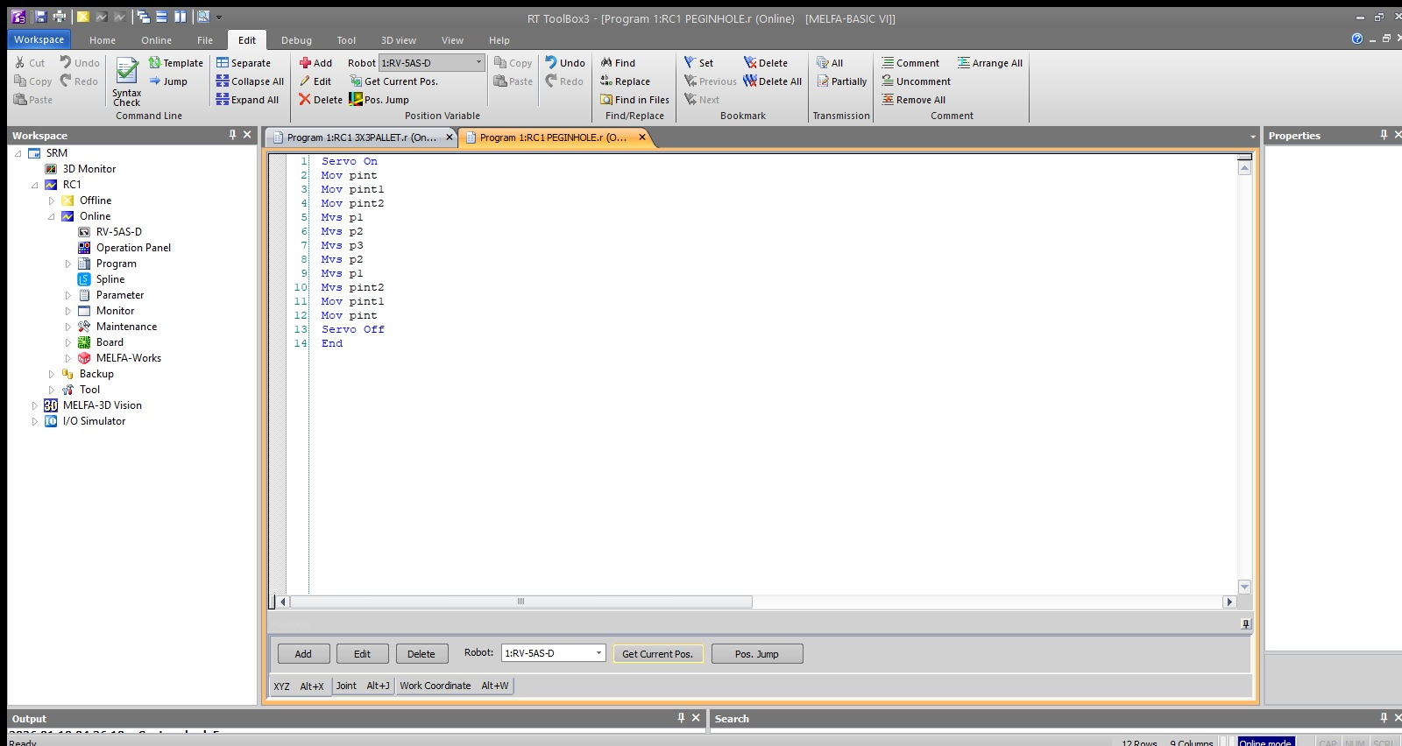
Figure 2: Program Editor in RT ToolBox3 with MELFA-BASIC VI code, highlighting the shift from joint (Mov) to linear (Mvs) interpolation.
Expt No:  02 | KINEMATIC ALIGNMENT LOGIC AND MULTI-POINT SPATIAL MAPPING
Date:
04 / 02 /2026

- AIM:
To design and implement kinematic alignment strategies for high-precision robotic assembly tasks (Peg-in-Hole) utilizing intermediate alignment waypoints and axial approach vectors on a 6-axis industrial manipulator.

- APPARATUS REQUIRED:
  - Manipulator System: Mitsubishi RV-8CRL-D 6-axis industrial robot.
  - Control Hardware: CR800-D series dedicated robot controller.
  - Software Suite: RT ToolBox3 integrated engineering environment.
  - End-of-Arm Tooling : Precision-machined assembly base with high-tolerance receptacle holes and a corresponding "peg" end-effector.
  - Infrastructure: Solid installation platform and standard TCP/IP or standard USB communication interface.

- THEORY:
High-precision insertion tasks require the workpiece to be perfectly coaxial with its receptacle before final seating to prevent mechanical jamming or component damage.
- Core Principle:
Kinematic alignment utilizes a sequence of spatial waypoints to transition the Tool Center Point (TCP) from a general workspace area to a specific assembly axis. This ensures that the final insertion vector is purely axial.
- Working Mechanism:
  - Intermediate Waypoints (pint, pint1, pint2): These points serve as transition nodes that guide the robot to the insertion axis while clearing environmental obstacles.
  - Axial Approach via Linear Interpolation (Mvs): Once alignment is achieved, depth-based moves must be executed using Mvs. This ensures the TCP moves in a rigid straight line, maintaining the vertical orientation required for high-tolerance seating.
  - Coaxial Retraction: The exit path mirrors the insertion path linearly to avoid shearing forces against the receptacle walls.

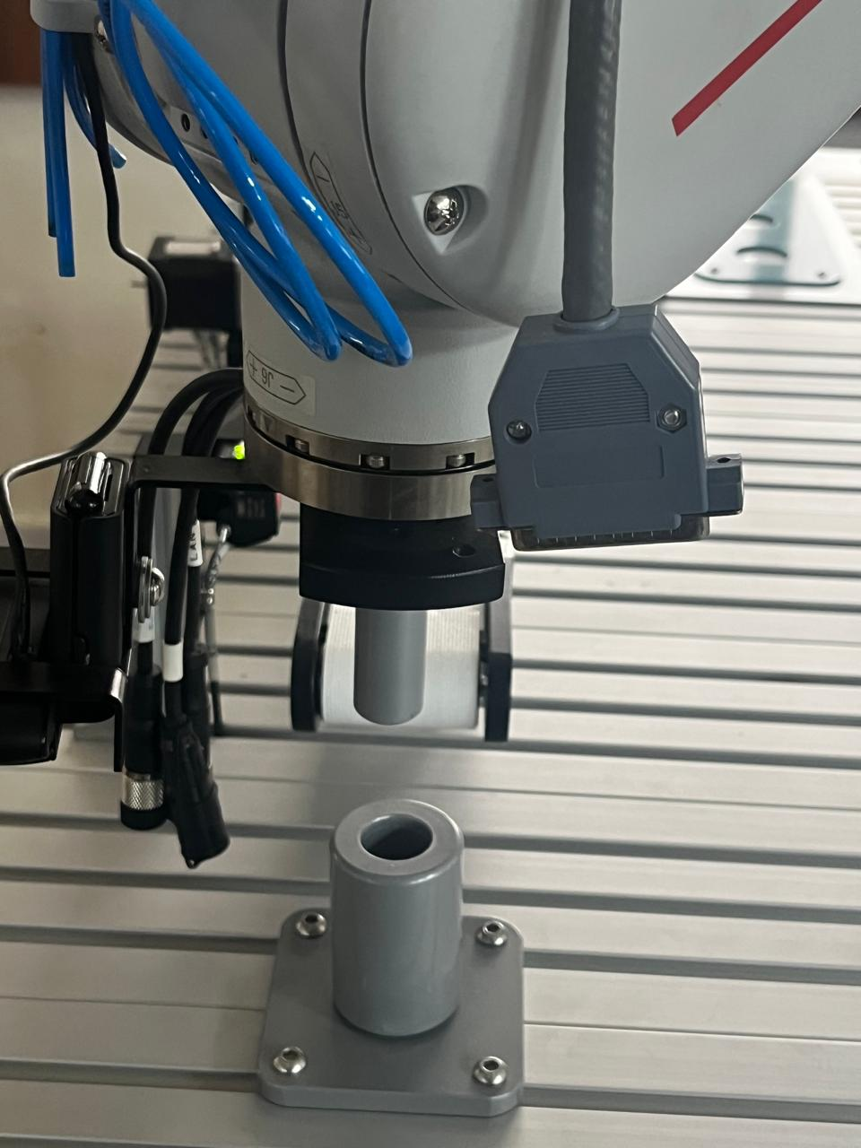
Figure 3: Mitsubishi RV-5AS-D manipulator aligned above the fixture before insertion.

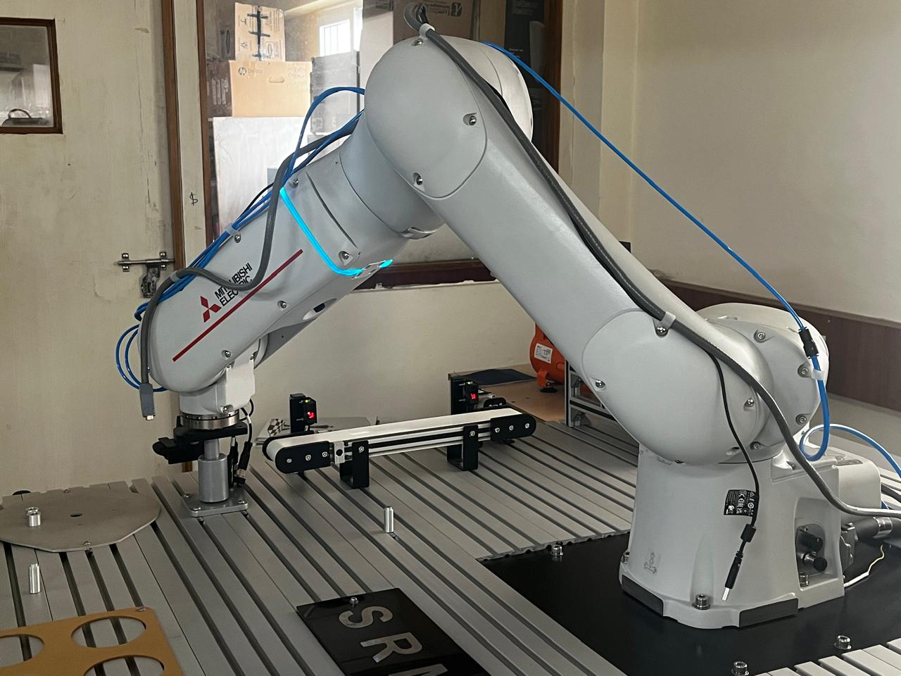
Figure 4: Live peg-in-hole assembly on the test bench.
- PROCEDURE:
- Setup & Connections:
Establish communication between RT ToolBox3 and the CR800 controller. Secure the assembly fixture and manually jog the robot using the teach pendant to define the seated assembly positions (p1, p2, p3) and the alignment nodes (pint, pint1, pint2).
- Algorithm & Logic:
  - Enable system servos and move to the global intermediate waypoint (pint).
  - Navigate through axis-alignment waypoints (pint1, pint2) to establish the approach vector.
  - Execute high-precision linear insertion through seating depths (p1 to p3).
  - Retract along the same axial path using linear interpolation.
  - Depart through the alignment waypoints to the home position and disable servos
- Execution Steps:
  - Perform a Step Run in manual mode to verify that the axial alignment between pint2 and p1 is perfectly vertical.
  - Check for potential "Axis Load" spikes using the Oscillograph tool during the linear depth moves (p1-p3) to ensure no mechanical binding occurs
  - Transition to Automatic mode for operational repeatability testing.
- Observation Instructions:
Visually monitor the insertion to ensure there is no lateral deflection of the manipulator arm. Verify the precision of the TCP relative to the target receptacle using the Cur pos display in the software.

- RESULT AND OBSERVATION:
The robotic system successfully achieved high-precision kinematic alignment. The use of multi-point mapping and rigid linear interpolation ensured consistent coaxial insertion and retraction without mechanical interference, as verified by functional evaluation.

